The Objective of the Sales Dashboard / Business Problem
The objective of the report is to analyze and present comprehensive insights into sales, profit, orders, profit margin, and various comparisons. It aims to provide a clear understanding of key performance indicators and trends using Power BI. The report objectives can be summarized as follows:
- Calculate Total Sales: Calculate and display the total sales value for the selected period, allowing users to understand the overall revenue generated.
- Calculate Profit: Calculate and visualize the total profit achieved based on the sales data, providing insights into the financial performance.
- Analyze Orders: Analyze the number of orders placed during the selected period, helping to identify sales patterns and order trends.
- Calculate Profit Margin: Calculate and visualize the profit margin percentage, enabling users to assess the profitability of products or services.
- Compare Sales by Product with Previous Year: Compare sales performance for each product between the selected period and the previous year, highlighting growth or decline in sales.
- Compare Sales by Months with Previous Year: Compare sales performance across different months between the selected period and the previous year, identifying regions with significant changes.
- Display Top 5 Cities: Present a visualization showcasing the top 5 cities based on sales, allowing users to quickly identify the most lucrative locations.
- Compare Profit by Channel with Previous Year: Compare profit generated by each channel between the selected period and the previous year, indicating improvements or challenges in profitability.
- Analyze Sales by Customer and Compare with Previous Year: Analyze sales data by customer, highlighting the performance of individual customers and comparing it to the previous year.
- Create Slicers for Date, City, Product, and Channel: Enable users to interact with the data by providing slicers for selecting specific dates, cities, products, and channels, allowing for dynamic filtering and personalized analysis.

BUSINESS PROBLEM > LOAD DATA > DATA CLEANSING > DATA MODELING > DATE TABLE > REPORT DASHBOARD > PUBLISH REPORT
STEPS TO FOLLOW FOR AN END-TO-END POWER BI PROJECT
- GATHER DATA
- POWER QUERY - DATA EXTRACT, TRANSFORM AND LOAD
- CREATE A DATE TABLE BY HIGHLIGHTING ORDER DATE IN THE SALES TABLE > CREATING NEW TABLE > Date = CALENDARAUTO()
In the table view I added two new columns called YEAR and MONTH with the formulas as follows:
Year = YEAR(DateTable[Date])
Month = FORMAT(DateTable[Date], "mmm")

- CREATE DATA MODEL IN POWER BI DESKTOP
- DEVELOPMENT REPORTS IN POWER BI DESKTOP
- Create Report Background in Powerpoint
- Create Slicers for DATE(year, month), CITY, PRODUCT and CHANNEL
- Create Dax Measures
- Create visuals

IMPLEMENTING DAX CALCULATIONS – CALCULATED COLUMNS, MEASURES AND CALCULATED TABLES TO PERFORM COMPLEX CALCULATIONS AND AGGREGATIONS
Calculated column > Sales_data table > Total Profit = Sales_Data[Sales] - Sales_Data[Total_Cost]
In the Table View I created another table named Measure Table, then I clicked in the Report View and created the following measures:
Measure Table > Total Sales = SUM(Sales_Data[Sales])
Measure Table > Sales Previous Year 1 = CALCULATE([Total Sales], SAMEPERIODLASTYEAR(DateTable[Date]))
I could have also used the time intelligence function DATEADD Sales Previous Year 2 = CALCULATE([Total Sales], DATEADD(DateTable[Date], -1, YEAR))
Measure Table > Total Sales vs Previous Year = [Total Sales] - [Sales Previous Year 1]
Measure Table > Total Sales vs Previous Year % = [Total Sales vs Previous Year] / [Total Sales]
Measure Table > Total Profit = SUM(Sales_Data[Total Profit])
Measure Table > Profit Previous Year 1 = CALCULATE([Total Profit], SAMEPERIODLASTYEAR(DateTable[Date]))
I could have also used the time intelligence function DATEADD Profit Previous Year 2 = CALCULATE([Total Profit], DATEADD(DateTable[Date], -1, YEAR))
Measure Table > Total Profit vs Previous Year = [Total Profit] - [Profit Previous Year 1]
Measure Table > Total Profit vs Previous Year % = [Total Profit vs Previous Year] / [Total Profit]
Measure Table > Profit Margin = DIVIDE([Total Profit], [Total Sales],0)
Measure Table > Total COGS = SUM(Sales_Data[Total_Cost])
Measure Table > Total Order Quantity = SUM(Sales_Data[Order Quantity])

CREATE VISUALS

Line and Clustered Column Chart with current year Total Sales and Sales Previous Year broken down by Product Name
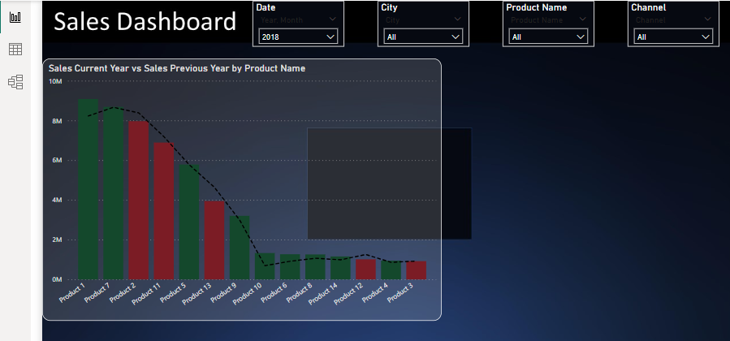
CONDITIONAL FORMATTING: VISUAL - COLUMNS - NEW RULE
If Current Year Sales Vs Previous Year >= 0 and < than the maximum, its colour will change to green
If Current Year Sales Vs Previous Year >= Minimum and < than 0, then its colour will change to red
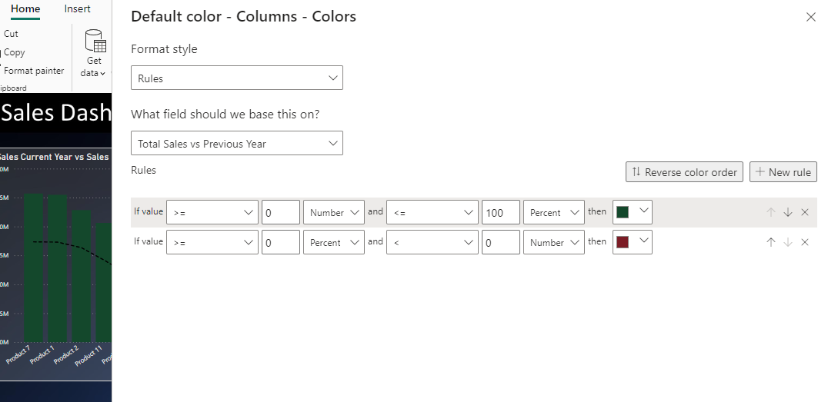

SAME AS BEFORE BROKEN DOWN BY MONTH NAME

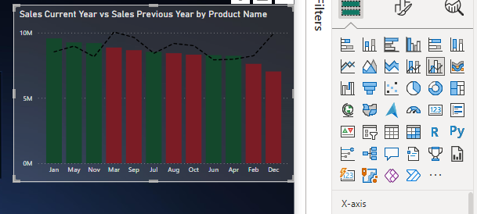

Donut Chart showcasing Total Sales by city
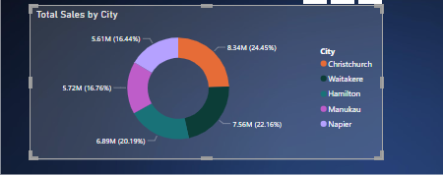

Area chart showing Total Profit, Profit Previous Year & Profit Margin by Channel
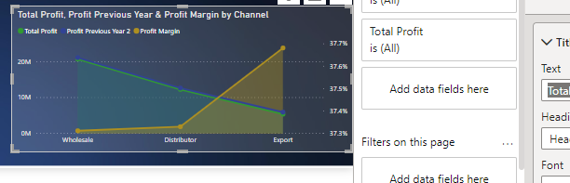

Clustered Bar Chart showcasing TOTAL SALES AND SALES PREVIOUS YEAR BY CUSTOMER
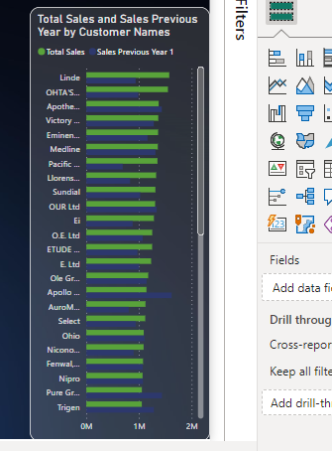
CARDS TO VISUALISE TOTAL SALES, TOTAL PROFIT, PROFIT MARGIN, TOTAL ORDER QUANTITY
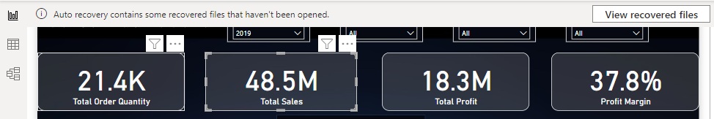
Finally, I created a duplicate of the Sales Dashboard page and a new page too with the same visuals but in a different format.

CONCLUSION FOR THE YEAR 2019:
- Sales decreased by more than 10%
- There is a drop in sales of all the top 7 Products
- 4 Customers are leading to a drop in sales
- The profit margin in the Export channel is higher

